EX NO: 1 – IDENTIFIES A SOFTWARE SYSTEM THAT NEEDS TO BE DEVELOPED -SUGANYA M-8649
PROJECT TITLE: Exam Registration System
OBJECTIVE:
The objective of this project is to design and develop an Exam Registration System that enables students to register for their semester exams seamlessly. The system will automate the entire process from subject selection to fee payment and hall ticket generation, ensuring transparency, accuracy, and time efficiency. The system will be modular and user-friendly, catering to both students and administrators.
PROBLEM STATEMENT:
In many academic institutions, exam registration is still conducted manually or using outdated platforms, leading to various challenges such as data inconsistency, registration errors, long queues, and delayed processing. Manual verification of fee payments and hall ticket distribution can be tedious and error-prone. This project aims to eliminate these issues by providing an efficient, secure, and automated exam registration system that can be integrated with existing academic databases.
SCOPE OF THE SYSTEM:
- Secure login system for students and administrators
- Subject-wise exam selection interface
- Online fee calculation and payment gateway integration
- Automated hall ticket generation and printing
- Admin portal for monitoring registrations, payment status, and report generation
- Notifications and alerts for registration deadlines

EX NO: 2 – DOCUMENT THE SOFTWARE REQUIREMENTS SPECIFICATION (SRS) -SUGANYA M-8649
1. INTRODUCTION
1.1 Purpose
The Exam Registration System is designed to simplify and digitize the process of semester exam enrollment for students. It helps in subject selection, fee payment, and hall ticket generation, ensuring a smooth and error-free process.
1.2 Scope
- Allows students to register for exams and make online payments.
- Enables admins to verify payments and approve applications.
- Generates hall tickets and exam schedules automatically.
- Maintains registration history and generates reports.
1.3 Definitions, Acronyms, and Abbreviations
- ERS – Exam Registration System
- Admin – Staff responsible for managing exam registration
- Student – End user registering for exams
1.4 References
• College Examination Manual (2023 Edition)
• UGC Guidelines for Online Exam Registration
• UML Diagrams and Use Case Modeling, Pearson Publications
2. OVERALL DESCRIPTION
2.1 Product Perspective
ERS is a centralized web-based platform for managing student exam registration and hall ticket distribution.
2.2 Product Functions
- Student login and registration
- Subject/course selection
- Fee payment and verification
- Hall ticket generation and printing
- Admin dashboards and reports
2.3 User Characteristics
- Admin – Manages student registrations and payment validation
- Student – Registers for exams, selects subjects, downloads hall ticket
2.4 Constraints
- Fee must be paid to complete registration
- System accessible only within the college domain
- Hall ticket issued only after admin approval
3. SPECIFIC REQUIREMENTS
3.1 Functional Requirements
3.1.1 Student Registration
- Students shall log in and select subjects for registration.
3.1.2 Payment Verification
- Admin shall verify fee payments before generating hall tickets.
3.1.3 Hall Ticket Generation
- System shall generate a PDF hall ticket after approval.
3.2 Non-Functional Requirements
- Should support at least 200 concurrent users
- Response time should be below 2 seconds

3.3 Interface Requirements
- GUI: Web interface for registration and admin panel
- Database: MySQL for storing user and registration data

EX NO: 3 – IDENTIFY USE CASES AND DEVELOP THE USE CASE MODEL
-SUGANYA M-8649

USE CASE DIAGRAM:

EXAM REGISTRATION SYSTEM
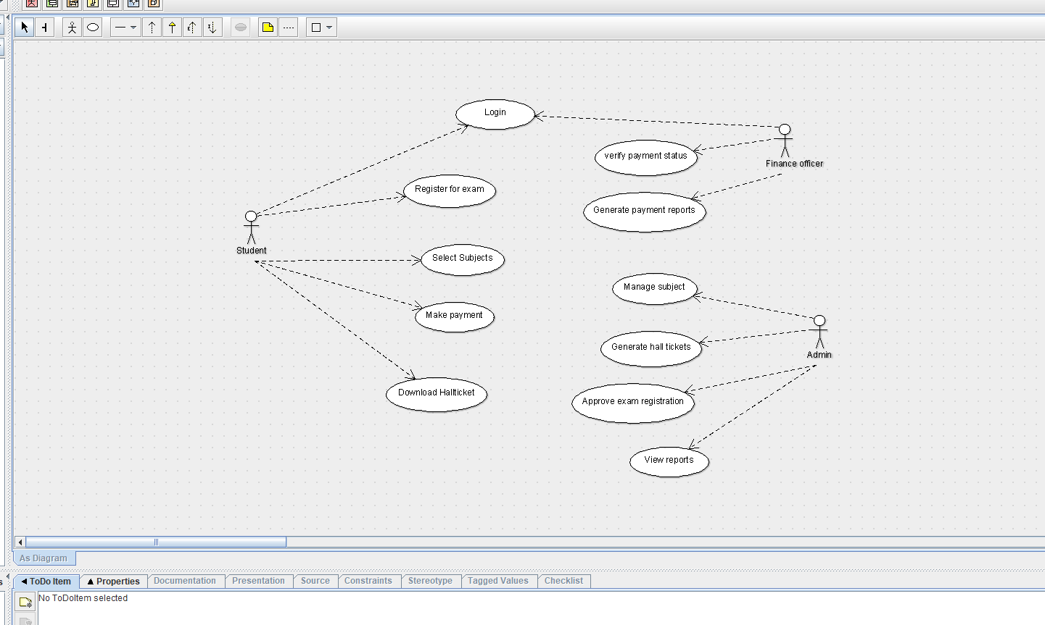

EX NO: 4 – IDENTIFY CONCEPTUAL CLASSES; DEVELOP DOMAIN MODEL & CLASS DIAGRAM -SUGANYA M-8649
CLASS DIAGRAM:

EXAM REGISTRATION SYSTEM
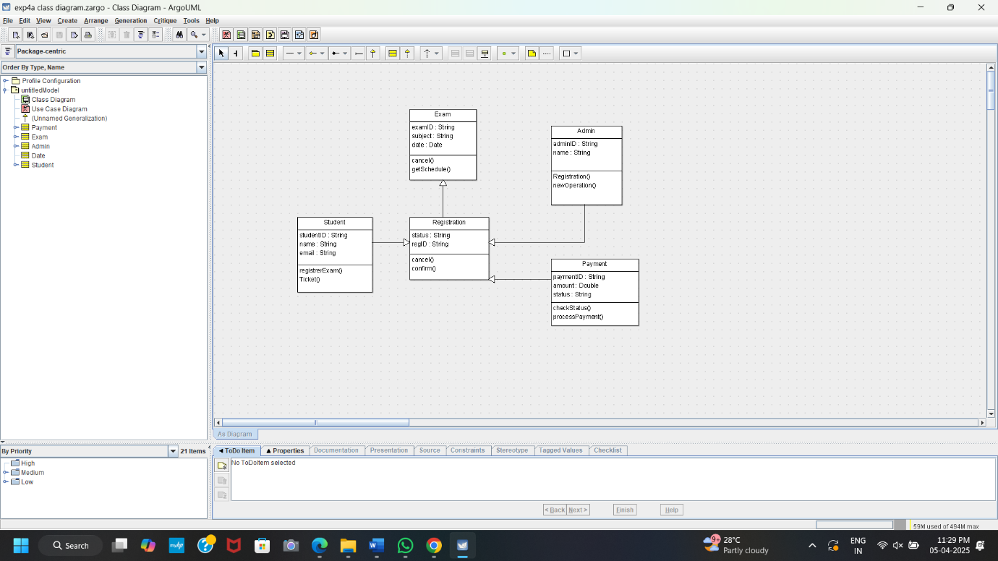

EX NO: 5 – USING THE IDENTIFIED SCENARIOS, FIND THE INTERACTION BETWEEN OBJECTS AND REPRESENT THEM USING UML SEQUENCE AND COLLABORATION DIAGRAM -SUGANYA M-8649

1. SEQUENCE DIAGRAM:

EXAM REGISTRATION SYSTEM
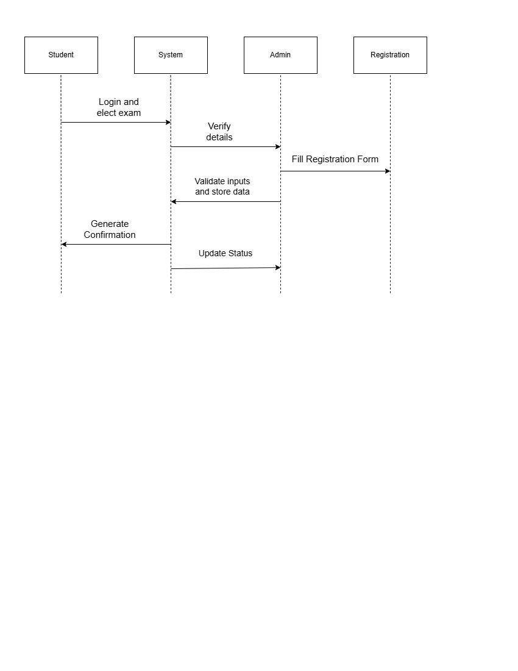

2. COLLABORATION DIAGRAMS

EXAM REGISTRATION SYSTEM
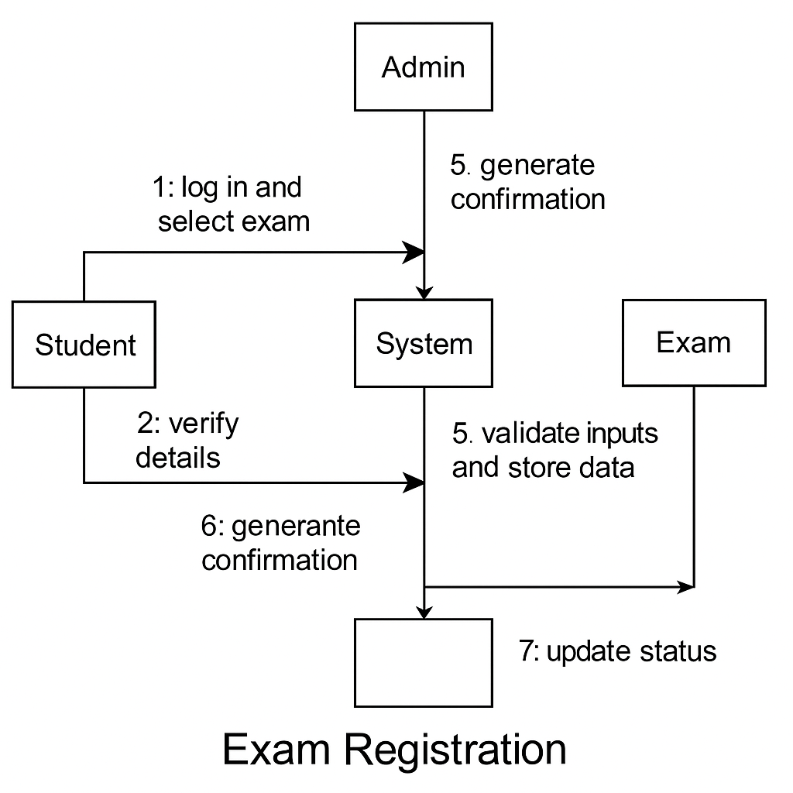

EX NO: 6 DRAW RELEVANT STATE CHART AND ACTIVITY DIAGRAMS FOR THE SYSTEM -SUGANYA M-8649

STATE CHART DIAGRAM:

EXAM REGISTRATION SYSTEM
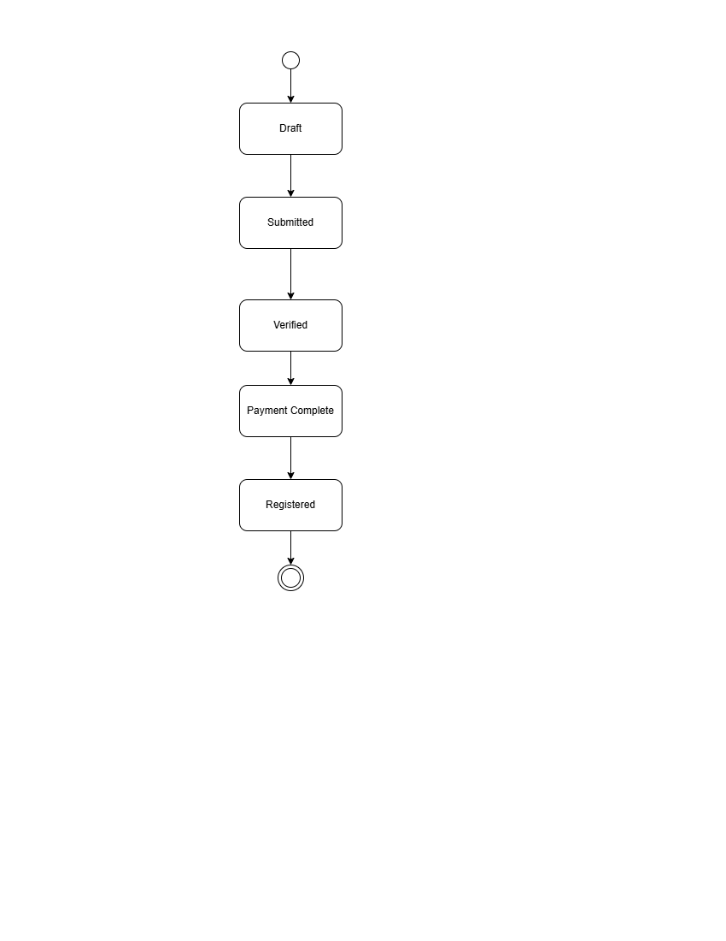

ACTIVITY DIAGRAM:
EXAM REGISTRATION SYSTEM
